**6.2.2 Mouse scroll wheel**

If the RX window is full of text, and some text has scrolled off, you can pause the RX window by placing the Mouse cursor anywhere in the RX window and rotate the scroll wheel. This function will suppress incoming data, allowing the user to scroll the existing text without interruption by incoming text.  While scrolling, this pause function is visually indicated by the word “Freeze…” in the upper left hand corner of the header. Data will continue to be decoded, but will not print. Freeze mode will time-out and self-cancel if no further scrolling is detected. If the cursor is moved away from the receive pane, freeze mode is immediately canceled and incoming text printing is resumed.



SCDW_53

The “Freeze” function is enabled by opening “View | Rx window options” and checking “Enable receive Freeze”.

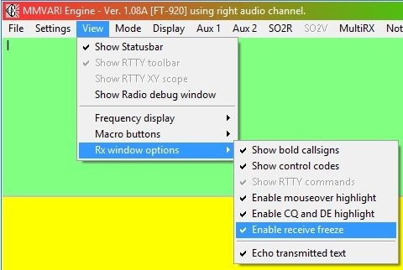

SCDW_53A